**Fall Term CS Final Name:**

**Directions: You may not use a computer or consult any resources.**

1. What is the output of this code?

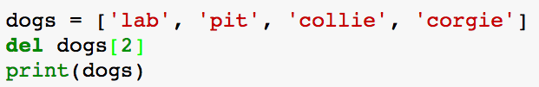

a. ['lab', 'pit', 'corgie']

b. ['lab', ‘collie’, 'corgie']

c. A Type error because 2 is not in the list.

d. ‘collie’

________________________________________________________________

2. What is the output of this code?

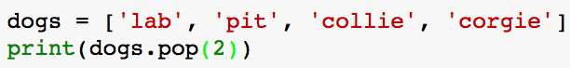

a. ['lab', 'pit', 'collie', 'corgie']

b. ['lab', ‘collie’, 'corgie']

c. A Type error because 2 is not in the list.

d. ‘collie’

________________________________________________________________

3. What will be the output of this code?

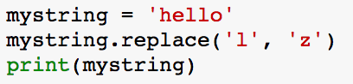

a. ‘hello’ because mystring was not updated

b. ‘hezzo’ because both l’s were replaced

c. ‘hezlo’ because only the first l was replaced

________________________________________________________________

4. What will be the output of this code?

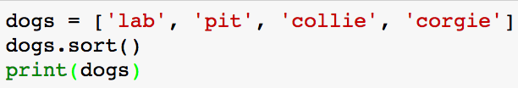

a. [‘collie’, ‘corgie’, ‘lab’, ‘pit’]

b. None

c. [‘lab’, ‘pit’, ‘collie’, ‘corgie’]

5. What will be the output of this code?

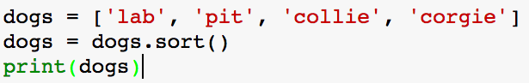

a. [‘collie’, ‘corgie’, ‘lab’, ‘pit’]

b. None

c. [‘lab’, ‘pit’, ‘collie’, ‘corgie’]

________________________________________________________________

6. What is the output of this code?

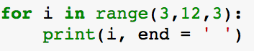

a. 3 6 9 12 b. 3 6 9 c. 6 9 d. 6 9 12

________________________________________________________________

7. What is the output of this code?

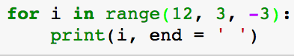

a. 12 9 6 3 b. 12 9 6 c. 9 6 3 d. 9 6

________________________________________________________________

8. Calculate:

a. 10 % 3 = b. 10 % 2 = c. 10 % 4 = d. 10 % 20 =

________________________________________________________________

9. What is the output of the following code?

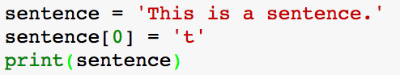

a. ‘this is a sentence.’ because strings are mutable

b. ‘this is a sentence.’ because strings are immutable

c. A TypeError because strings are mutable.

d. A TypeError because strings are immutable.

10. What is the output of the following code?

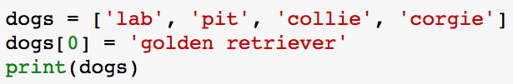

a. [‘golden retriever’, ‘pit’, ‘collie’, ‘corgie’] because lists are mutable

b. [‘golden retriever’, ‘pit’, ‘collie’, ‘corgie’] because lists are immutable

c. A TypeError because lists are mutable.

d. A TypeError because lists are immutable.

________________________________________________________________

11. What is the error in this code called?

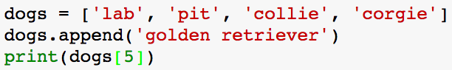

a. A TypeError b. An IndexError c. An AttributeError d. An IndentationError

________________________________________________________________

12. What is the output of this code?

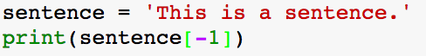

a. ‘.’

b. ‘This is a sentence’

c. ‘his is a sentence.’

d. ‘.ecnetnes a si sihT’

________________________________________________________________

13. What is the output of this code?

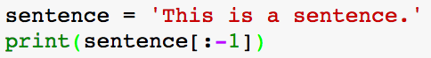

a. ‘.’

b. ‘This is a sentence’

c. ‘his is a sentence.’

d. ‘.ecnetnes a si sihT’

________________________________________________________________

14. What is the output of this code?



a. ‘.’

b. ‘This is a sentence’

c. ‘his is a sentence.’

d. ‘.ecnetnes a si sihT’

15. What is the output of this code?

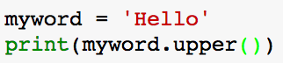

a. False

b. True

c. None

d. HELLO

________________________________________________________________

16. What is the output of this code?

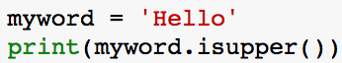

a. False

b. True

c. None

d. HELLO

________________________________________________________________

17. What is the output of this code?

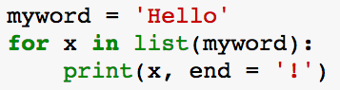

a. b. c. d. Error



________________________________________________________________

18. What is the output of this code?

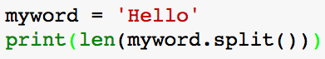

a. 0 b. 1 c. 5 d. Error

________________________________________________________________

19. Find the error in this code and fix it so that it prints out each dog on a different line. Do not change the print statement.

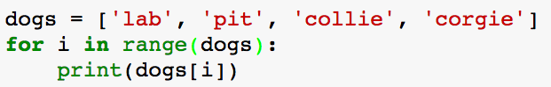

20. Change one thing in this input:

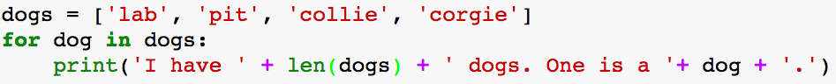

so that it prints out this output:

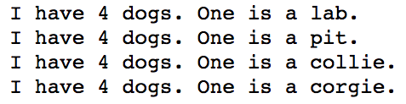

________________________________________________________________

21. What is the output of this code?

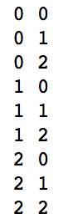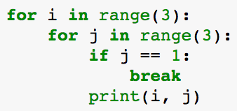

a. b. c. d.

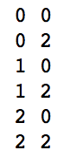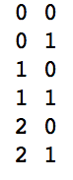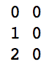

________________________________________________________________

22. What is the output of the following code?

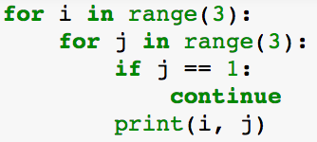



a. b. c. d.



23. What will the output of this code be?

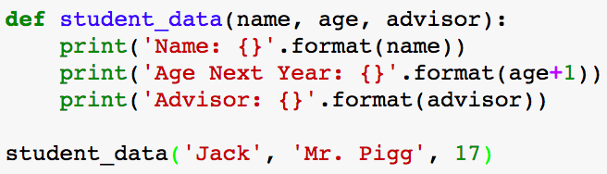

a.

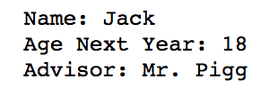

b. A TypeError because __________________________.

________________________________________________________________

24. What will the output of this code be?

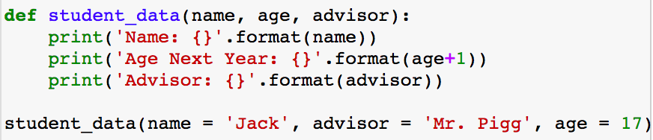

a.



b. A TypeError because __________________________.

________________________________________________________________

25. Explain what this code is doing in the context of a raffle:

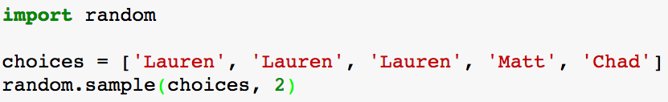

26. Fill in the appropriate blanks so that this code:

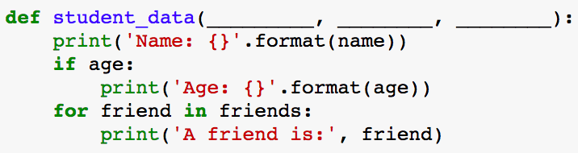

produces this:

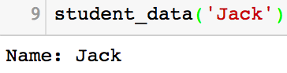

and this:

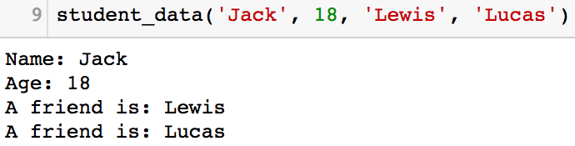

________________________________________________________________

27. Consider the following plot of the sine function:

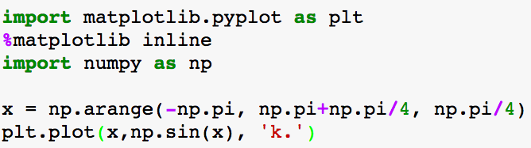

a. What is the x-coordinate of the first dot plotted?

b. What is the x-coordinate of the last dot plotted?

c. What is the color of the dots?

28. You want to write a program that asks the user for their favorite sport. If their favorite sport is soccer, you want to ask if they prefer indoor or outdoor. If their favorite sport is indoor, print “That is my favorite game, too!” If they prefer a sport other than soccer or if they prefer outdoor soccer, print “Meh, that is not my favorite sport.” Explain why this code does not produce the correct program:

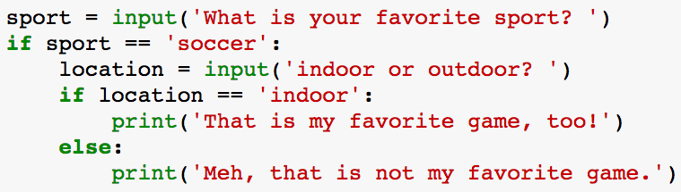

Explanation:

________________________________________________________________

29. Fix the above code using a Boolean variable called fave_game.

________________________________________________________________

30. Write a **function** that takes in a positive integer n and returns the factorial of that number without using the math.factorial function.

________________________________________________________________

31. The code below tests whether a number n>=2 is prime or not.

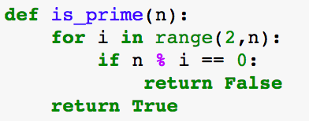

Write a code that references the is_prime function above to print all of the primes between two numbers, inclusive. Here is a sample output:

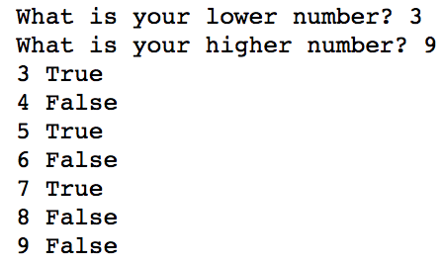

32. Write a code that asks the user for a number and produces the following output:

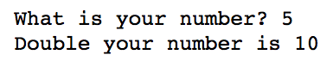

33. Write a code that asks the user for a list of numbers on one line and prints double each number on different lines:

